**Cambodian modernism**

Cambodian modernity was chiefly shaped by the forces of colonisation, decolonisation, and the Cold War. These had singular consequences for art and culture in Cambodia, in turn shaping a distinct Cambodian modernism. From the establishment of a national art school in 1918, until the 1940s, Cambodian artists were forbidden from forms that were perceived to be European. This was the result of a strict cultural policy designed to preserve and protect what were thought of as authentically traditional Cambodian arts and crafts. In the 1950s and 1960s, during King Norodom Sihanouk’s independent Cambodian *Sangkum Reastr Niyum* (People’s Socialist Community), the arts flourished as a key site for articulating a new nationalist identity. But the promise of this period—popularly remembered as a cultural ‘golden age’—was shattered by violent political upheavals, beginning with the outbreak of civil war in 1970. During Pol Pot’s Khmer Rouge regime of 1975-79, approximately 1.7 million Cambodians perished, including an estimated ninety per cent of all artists and intellectuals. Under the regime, most familiar forms of art and culture were forbidden. In 1979, invading Vietnamese forces ousted the Khmer Rouge and in the following decade artistic production focused on rebuilding after devastation. Finally, the 1992-93 United Nations occupation of Cambodia heralded a new era of transnational cultural exchanges, often based in discourses of aid and development.

**Modernism under colonisation**

Even before the temples of Angkor were built in the twelfth century CE, Cambodian contact with Asian and, later, European explorers and traders was frequent and extensive. Yet it was under the establishment of the French Protectorate of *Cambodge* in 1863 that a Cambodian modernity emerged. Among the earliest examples of Cambodian modernism are negotiations between longstanding Khmer traditions and imposed French demands. Historian Penny Edwards offers the 1870 establishment of a Royal Palace in Phnom Penh as a prime example of this. The palace was constructed in brick and stone, at the insistence of the French, who found the wooden structures of previous royal residences insufficiently grand and worrisomely impermanent. Yet each of the numerous small buildings within the palace compound was lavishly adorned with Khmer *kbach*, a codified system of ornamentation in continuous use since before Angkor. Roofs were modeled on *stupas* (Buddhist funerary structures). A mural was later added depicting scenes from the *Reamker*, Cambodia’s adaptation of the Indian *Ramayana*.

During the first decades of colonial rule, royals and other wealthy Cambodians developed a taste for imported designs in clothing and ornaments. These complemented and sometimes displaced their longstanding patronage of Khmer silks, silverware and other forms. The French reacted to this with dismay, fearing that Cambodian culture would soon vanish. In 1918, George Groslier established the *Musée Albert Sarraut* (later National Museum of Cambodia) and É*cole des Arts Cambodgiens.* This school instituted a curriculum that strictly forbade anything perceived to be European, insisting instead on the careful copying of existing Khmer traditions. While *Écoles des Beaux-Arts* elsewhere in Indochina during this period, included tuition in drawing from life and reinvention of older techniques such as lacquer, early Cambodian modernism was often visually indistinguishable from pre-colonial visual production. However, it was produced under significantly altered circumstances, and with copying the only permissible technique.

In the 1940s, following Groslier’s death and a brief Japanese military occupation, the curriculum at the *École des Arts Cambodgiens* transformed to include new forms of drawing from life, including *plein air* painting. Under the tutelage of a French-trained Japanese painter named Suzuki, students began to depict scenes of Angkorean temples as well as daily life.

**Independent Cambodia: modernism’s ‘golden age’**

The spirit of innovation initiated in the visual arts during the 1940s intensified and expanded following the 1953 declaration of Cambodian independence. Norodom Sihanouk, who ruled in various capacities from 1953 until 1970, was a singer, filmmaker, and patron of the arts. He enthusiastically sponsored cultural expression while also utilising it to articulate a Cambodian national identity that simultaneously asserted youthful novelty and an Angkorean lineage.

Landscape painting became the predominant visual art form, with painters such as Nhek Dim and Men Makot depicting scenes of agricultural life for the enjoyment of urbanites in Phnom Penh as well as Paris. Views of Angkor Wat and other temples also increased in popularity, as well as realist and romantic portraiture.

Following the production of the first Cambodian feature film in 1960, cinema exploded in popularity. Many filmmakers received training and inspiration from US-sponsored soft diplomacy programs. Cities and rural towns were dotted with theatres showing films such as *The Golden Swan (Sovannahong)* (director Yvon Hem, 1967)*,* which drew on Khmer mythology, and *Khmers After Angkor (Orn Euy Srey Orn)* (director Ly Bun Yim, 1972) which romanticized rural life while also highlighting the suffering of impoverished farmers and the greed of corrupt officials and elites.

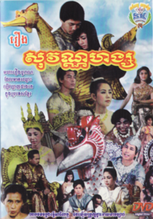

Yvon Hem (director), *Sovannahong (The Golden Swan)*, 1967. Copyright 2001 Siam Film Development/Studio Bangkok/Thunya Nilklang. <http://en.wikipedia.org/wiki/Cinema_of_Cambodia#mediaviewer/File:Sovannahong.png> ]

Social commentary was also a common theme in the literature of the period. Novels such as *Preah Aatit Thmey Reah Ler Pen Dey Jah* *(New Sun Rises Over the Old Land)* by Suon Sorin (1959) contrasted the hardships of urban poverty with the excesses enjoyed by *okhnha* (indigenous elites) and ‘foreign capitalists.’

Popular music, closely linked to the burgeoning film industry, became the soundtrack to Cambodian modernism. Singers such as Sinn Sisamouth, Ros Sereysothea and Sihanouk himself combined a crooning vocal style with rock ’n roll rhythms in countless love songs, as well as hits such as *Battambang* and *Phnom Penh* that poetically celebrated the qualities of modern Cambodia.

New dances and theatrical (*lkhon*) works were created, in both classical court traditions and folk forms. Under the tutelage of Chheng Phon, students at the Royal University of Fine Arts (formerly *École des Arts Cambodgiens*) undertook research trips to provincial areas during the 1960s. *Coconut Dance (Trolaok)* was among the more popular new dances choreographed with inspiration from rural life. The *Apsara* dance, which utilized ancient gestures known as *kbach baat*, was choreographed during the 1950s and first performed by Princess Buppha Devi. These and many other new adaptations of existing performance forms were presented by the palace as defining the new Cambodian national identity. Performance troupes ceaselessly toured Cambodia’s provinces, and visiting politicians were treated to elaborate performances in the capital, sometimes incorporating specially adapted lyrics or even the brandishing of American, Russian and other national flags.

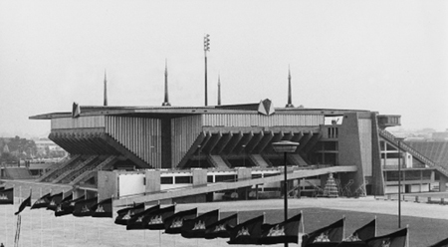

Vann Molyvann (architect), *National Sports Complex*, 1964. Vann Molyvann Collection. <http://www.vannmolyvannproject.org/IMAGES.html> ]

Architecture in newly independent Cambodia vernacularised the ‘International Style’ to local climatic and lifestyle conditions. The best-known and most influential Cambodian modernist architect is Vann Molyvann, who was educated under Le Corbusier in Paris and appointed Minister of Culture after his return to Phnom Penh. His *National Sports Complex* (1964), *Independence Monument* (1958) and *Chaktomuk Conference Hall* (1961) fused new technologies with an environmentally sustainable approach to climate—especially water—that was inspired by the engineering infrastructure of Angkor. Molyvann’s architecture thus epitomized the hybridity of modernist Cambodian nationalism: its fusing of the mythology of ancient Angkor with a utopian celebration of the new.

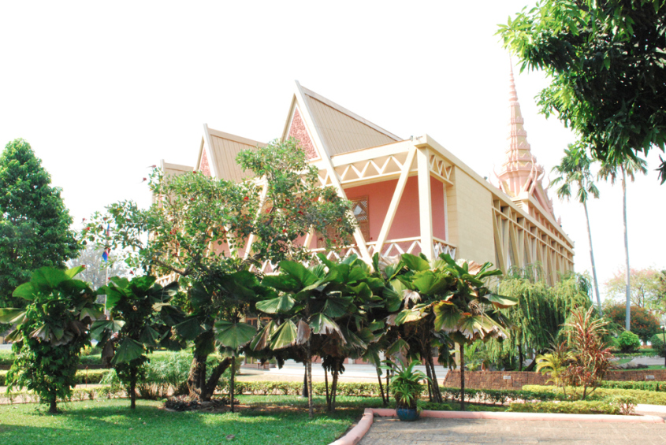

Vann Molyvann (architect), *Chaktomuk Conference Hall*, 1961. Photograph by Pen Sereypagna. <http://architectureofcambodia.wordpress.com/2013/10/27/chaktomuk-conference-hall/>

**The 1970s: rupturing the narrative of Cambodian modernism**

A coup in 1970 saw Sihanouk ousted from power and Molyvann exiled. The cinema, popular music, dance and theatre industries enjoyed continuing success despite escalating civil war, while visual art was increasingly employed as propaganda and construction of new buildings slowed.

Following Pol Pot’s victory on 17 April 1975, Cambodian society was immediately and radically transformed. Cities were forcibly evacuated, and urban cultural forms were specifically targeted by the genocidal Khmer Rouge regime. It is sometimes suggested that modernity stopped with Pol Pot’s declaration of ‘Year Zero,’ but the extremist agrarian revolution can also be understood as another kind of cruelly distorted modernist utopianism. Nearly all existing art forms were forbidden, with new propaganda songs and dances the primary forms of Cambodian modernism from 1975 until the regime’s fall in 1979. These were to varying degrees inspired by Chinese Socialist Realism, and eschewed the lavish costumes that characterised Cambodian performances before and after these years of terror.

**Cambodian modernism after 1979**

In 1979, invading Vietnamese forces ousted the Khmer Rouge. Rebuilding the arts was identified early as a priority of the new regime, arguably as a means to legitimize their rule among a wary population. Those few dancers, musicians and other performers to have survived the genocide were offered housing and tuition in Phnom Penh, and sent on regular tours of the Cambodian provinces as well as sometimes of Soviet states. Several dozen students of visual art were sent to Soviet states for their education, returning to fuse socialist realist painting with more recognisably Cambodian forms including landscapes and *kbach* ornamentation.

In 1992-93, the United Nations occupied Cambodia, and since then the national economy has depended heavily on international aid. Non-governmental organisations have been the primary sponsors of Cambodian arts and crafts in these years, with funding and opportunities primarily framed by national ‘development’ discourse. Governmental support for the arts is limited, and focuses on forms now thought of as ‘traditional,’ rather than on experimentation or innovation. Despite this, in the last decade numerous local and international commentators have heralded a ‘renaissance’ of Cambodian arts and culture. In the new millennium, artists have been working with media previously unknown in art contexts in Cambodia, including photography, video, interdisciplinary performance and participatory practices. Whether this is best thought of as a revival of Cambodian modernism or a shift into a Cambodian contemporary—or some combination of the two—remains an open question.

**References and Further Reading**

Edwards, Penny. (2007) *Cambodge: The Cultivation of a Nation, 1860-1945*, Chiang Mai: Silkworm Books.

Ly Daravuth and Muan, Ingrid. (2001) *Cultures of Independence: An Introduction to Cambodian Arts and Culture in the 1950's and 1960's,* Phnom Penh: Reyum Publishing.

Muan, Ingrid. (2001) “Citing Angkor: The ‘Cambodian Arts’ in the Age of Restoration 1918-2000,” PhD. Dissertation, Columbia University.

Shapiro, Toni. (1994) “Dance and the Spirit of Cambodia,” PhD. Dissertation, Cornell University.